Initial setup code:-

# =============================
# IMPORTS
# =============================
import pandas as pd
import numpy as np
import matplotlib.pyplot as plt

from sklearn.model_selection import train_test_split
from sklearn.metrics import mean_absolute_error, mean_squared_error, r2_score

from sklearn.preprocessing import OneHotEncoder, StandardScaler
from sklearn.compose import ColumnTransformer
from sklearn.pipeline import Pipeline
from sklearn.impute import SimpleImputer

from sklearn.ensemble import RandomForestRegressor
from xgboost import XGBRegressor

# =============================
# LOAD DATASET
# =============================
df = pd.read_csv('/kaggle/input/datasets/kesinisoujanya/airline-flight-delay-dataset-100k-records/flights.csv')

# =============================
# CLEAN COLUMN NAMES
# =============================
df.columns = df.columns.str.strip().str.lower()

# =============================
# 🔥 DROP USELESS COLUMNS (FIXED)
# =============================
df = df.drop(columns=['unnamed: 27', 'cancellation_code'], errors='ignore')

# =============================
# REMOVE DUPLICATES
# =============================
df = df.drop_duplicates()

# =============================
# REMOVE INVALID ROWS
# =============================
df = df[df['cancelled'] == 0]
df = df[df['diverted'] == 0]

# =============================
# REMOVE MISSING TARGET
# =============================
df = df.dropna(subset=['arr_delay'])

# =============================
# OPTIONAL: SPEED UP (sample data)
# =============================
df = df.sample(30000, random_state=42)

# =============================
# TARGET
# =============================
target = 'arr_delay'

# =============================
# FEATURE ENGINEERING
# =============================

# Date features
df['fl_date'] = pd.to_datetime(df['fl_date'], dayfirst=True, errors='coerce')
df = df.dropna(subset=['fl_date'])

df['day_of_week'] = df['fl_date'].dt.dayofweek
df['month'] = df['fl_date'].dt.month

# Time features
df['dep_hour'] = df['crs_dep_time'] // 100

# Flags
df['is_peak_season'] = df['month'].isin([6, 7, 12]).astype(int)
df['is_weekend'] = df['day_of_week'].isin([5, 6]).astype(int)

# Strong feature
df['delay_diff'] = df['arr_delay'] - df['dep_delay']

# Drop original date
df = df.drop(columns=['fl_date'], errors='ignore')

# =============================
# REMOVE DATA LEAKAGE
# =============================
df = df.drop(columns=[
'arr_time',
'wheels_on',
'actual_elapsed_time',
'air_time'
], errors='ignore')

# =============================
# FEATURES & TARGET
# =============================
X = df.drop(columns=[target])
y = df[target]

# =============================
# COLUMN TYPES
# =============================
cat_cols = X.select_dtypes(include=['object']).columns
num_cols = X.select_dtypes(exclude=['object']).columns

# =============================
# PREPROCESSING
# =============================
preprocessor = ColumnTransformer([
('num', Pipeline([
('imputer', SimpleImputer(strategy='median')),
('scaler', StandardScaler())
]), num_cols),

('cat', Pipeline([
('imputer', SimpleImputer(strategy='most_frequent')),
('encoder', OneHotEncoder(handle_unknown='ignore'))
]), cat_cols)
])

# =============================
# SPLIT
# =============================
X_train, X_test, y_train, y_test = train_test_split(
X, y, test_size=0.2, random_state=42
)

# =============================
# METRICS
# =============================
def evaluate(y_true, y_pred):
return {
"MAE": mean_absolute_error(y_true, y_pred),
"RMSE": np.sqrt(mean_squared_error(y_true, y_pred)),
"R2": r2_score(y_true, y_pred)
}

# =============================
# MODELS (FAST VERSION)
# =============================
models = {
"Random Forest": RandomForestRegressor(
n_estimators=50, # 🔻 reduced
max_depth=8,
random_state=42,
n_jobs=-1
),

"XGBoost": XGBRegressor(
n_estimators=100, # 🔻 reduced
max_depth=4,
learning_rate=0.1,
random_state=42,
n_jobs=-1,
verbosity=0
)
}

# =============================
# TRAIN
# =============================
results = {}

for name, model in models.items():

pipe = Pipeline([
('preprocessor', preprocessor),
('model', model)
])

pipe.fit(X_train, y_train)
y_pred = pipe.predict(X_test)

results[name] = evaluate(y_test, y_pred)

print(f"\n{name}")
print(results[name])

# =============================
# RESULTS
# =============================
results_df = pd.DataFrame(results).T
print("\nFinal Comparison:\n", results_df)

# =============================
# BEST MODEL
# =============================
best_model_name = results_df['R2'].idxmax()
print(f"\nBest Model: {best_model_name}")

# =============================
# VISUALIZATION
# =============================
plt.scatter(y_test, y_pred)
plt.xlabel("Actual Delay")
plt.ylabel("Predicted Delay")
plt.title(best_model_name)
plt.show()

Output:-
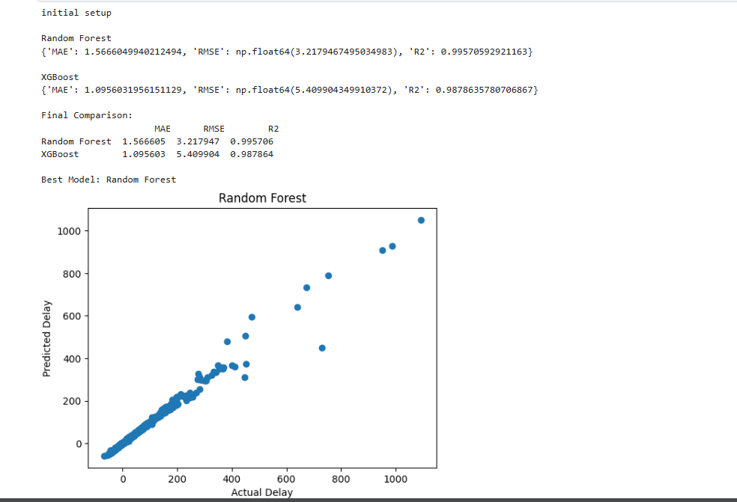

Research Question 1:- Baseline Performance
How effectively can baseline regression models predict flight arrival delays using the given dataset?

# =============================
# MODELS
# =============================
from sklearn.linear_model import LinearRegression
from sklearn.tree import DecisionTreeRegressor
from sklearn.neighbors import KNeighborsRegressor

models = {
"Linear Regression": LinearRegression(),
"Decision Tree": DecisionTreeRegressor(),
"KNN": KNeighborsRegressor()
}

results = []

for name, model in models.items():
pipe = Pipeline([
('prep', preprocessor),
('model', model)
])

pipe.fit(X_train, y_train)
preds = pipe.predict(X_test)

metrics = evaluate(y_test, preds)
metrics['Model'] = name
results.append(metrics)

df_results = pd.DataFrame(results)
df_results.to_csv("table1_baseline.csv", index=False)

# Plot
plt.figure()
plt.bar(df_results['Model'], df_results['RMSE'])
plt.title("Baseline Model RMSE")
plt.xticks(rotation=30)
plt.savefig("figure1_baseline.pdf")
plt.show()

Output:-
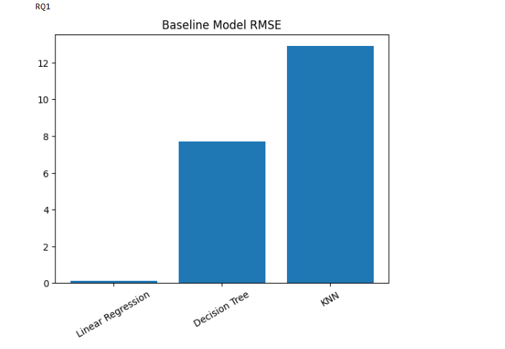
--------------------------------------------------------------------------------------------------------------------------------------

Research Question 2:- Model Comparison
Which machine learning model achieves the best predictive performance for flight delay prediction?

# =============================
# IMPORTS
# =============================
import pandas as pd
import numpy as np
import matplotlib.pyplot as plt

from sklearn.model_selection import train_test_split
from sklearn.metrics import mean_absolute_error, mean_squared_error, r2_score

from sklearn.preprocessing import OneHotEncoder, StandardScaler
from sklearn.compose import ColumnTransformer
from sklearn.pipeline import Pipeline
from sklearn.impute import SimpleImputer

from sklearn.linear_model import LinearRegression
from sklearn.ensemble import RandomForestRegressor, GradientBoostingRegressor

# =============================
# LOAD DATA
# =============================
df = pd.read_csv('/kaggle/input/datasets/kesinisoujanya/airline-flight-delay-dataset-100k-records/flights.csv')

# =============================
# CLEANING
# =============================
df.columns = df.columns.str.strip().str.lower()

# Drop useless columns
df = df.drop(columns=['unnamed: 27', 'cancellation_code'], errors='ignore')

# Remove duplicates
df = df.drop_duplicates()

# Remove invalid rows
df = df[df['cancelled'] == 0]
df = df[df['diverted'] == 0]

# Remove missing target
df = df.dropna(subset=['arr_delay'])

# Speed (optional)
df = df.sample(30000, random_state=42)

# =============================
# FEATURE ENGINEERING
# =============================
df['fl_date'] = pd.to_datetime(df['fl_date'], dayfirst=True, errors='coerce')
df = df.dropna(subset=['fl_date'])

df['day_of_week'] = df['fl_date'].dt.dayofweek
df['month'] = df['fl_date'].dt.month
df['dep_hour'] = df['crs_dep_time'] // 100

df['is_peak_season'] = df['month'].isin([6, 7, 12]).astype(int)
df['is_weekend'] = df['day_of_week'].isin([5, 6]).astype(int)

# Drop original date
df = df.drop(columns=['fl_date'], errors='ignore')

# Remove leakage
df = df.drop(columns=[
'arr_time', 'wheels_on', 'actual_elapsed_time', 'air_time'
], errors='ignore')

# =============================
# FEATURES / TARGET
# =============================
target = 'arr_delay'

X = df.drop(columns=[target])
y = df[target]

# =============================
# PREPROCESSING
# =============================
cat_cols = X.select_dtypes(include=['object']).columns
num_cols = X.select_dtypes(exclude=['object']).columns

preprocessor = ColumnTransformer([
('num', Pipeline([
('imputer', SimpleImputer(strategy='median')),
('scaler', StandardScaler())
]), num_cols),

('cat', Pipeline([
('imputer', SimpleImputer(strategy='most_frequent')),
('encoder', OneHotEncoder(handle_unknown='ignore'))
]), cat_cols)
])

# =============================
# SPLIT
# =============================
X_train, X_test, y_train, y_test = train_test_split(
X, y, test_size=0.2, random_state=42
)

# =============================
# METRICS
# =============================
def evaluate(y_true, y_pred):
return {
"MAE": mean_absolute_error(y_true, y_pred),
"RMSE": np.sqrt(mean_squared_error(y_true, y_pred)),
"R2": r2_score(y_true, y_pred)
}

# =============================
# MODELS (FAST + STRONG)
# =============================
models = {
"Linear Regression": LinearRegression(),

"Random Forest": RandomForestRegressor(
n_estimators=50,
max_depth=8,
random_state=42,
n_jobs=-1
),

"Gradient Boosting": GradientBoostingRegressor(
n_estimators=100,
max_depth=3
)
}

# =============================
# TRAIN & EVALUATE
# =============================
results = []

for name, model in models.items():

print(f"Training {name}...")

pipe = Pipeline([
('prep', preprocessor),
('model', model)
])

pipe.fit(X_train, y_train)
preds = pipe.predict(X_test)

metrics = evaluate(y_test, preds)
metrics['Model'] = name
results.append(metrics)

# =============================
# RESULTS TABLE
# =============================
df_results = pd.DataFrame(results)

# Sort for clarity
df_results = df_results.sort_values(by='R2', ascending=False)

print("\nModel Comparison:\n", df_results)

df_results.to_csv("table2_model_comparison.csv", index=False)

# =============================
# PLOT
# =============================
plt.figure()
plt.barh(df_results['Model'], df_results['R2'])
plt.title("Model Comparison (R2)")
plt.xlabel("R2 Score")
plt.tight_layout()
plt.savefig("figure2_model_comparison.pdf")
plt.show()

output:-

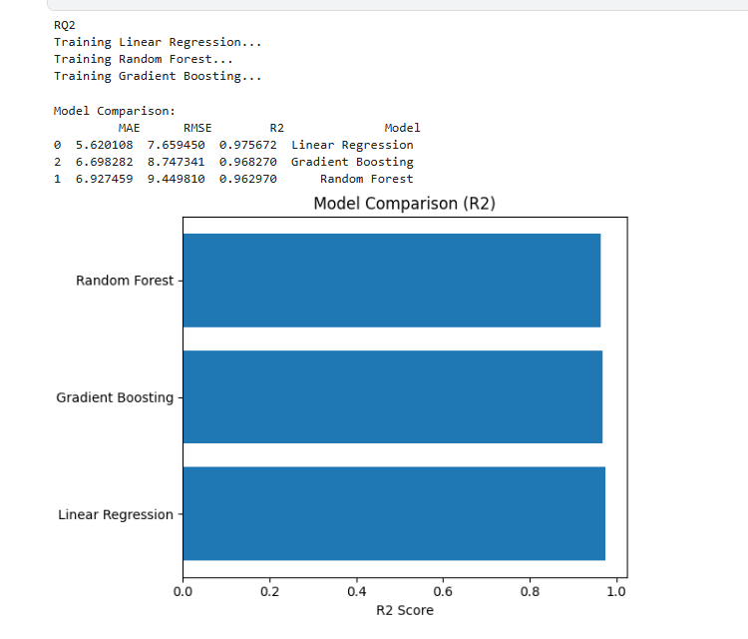

Research Question 3:- Effect of Preprocessing
How do different data preprocessing strategies affect model performance?

from sklearn.ensemble import RandomForestRegressor
from sklearn.impute import SimpleImputer

strategies = ["Raw", "Scaled"]

results = []

for strat in strategies:

if strat == "Raw":
prep = ColumnTransformer([
# Handle categorical
('cat', Pipeline([
('imputer', SimpleImputer(strategy='most_frequent')),
('encoder', OneHotEncoder(handle_unknown='ignore'))
]), cat_cols),

# Handle numeric (ONLY imputation, no scaling)
('num', Pipeline([
('imputer', SimpleImputer(strategy='median'))
]), num_cols)
])

else:
# Your existing full preprocessing (impute + scale)
prep = preprocessor

pipe = Pipeline([
('prep', prep),
('model', RandomForestRegressor(
n_estimators=50,
max_depth=8,
random_state=42,
n_jobs=-1
))
])

print(f"Running {strat} strategy...")

pipe.fit(X_train, y_train)
preds = pipe.predict(X_test)

metrics = evaluate(y_test, preds)
metrics['Strategy'] = strat
results.append(metrics)

# =============================
# RESULTS
# =============================
df_results = pd.DataFrame(results)
df_results = df_results.sort_values(by='R2', ascending=False)

print(df_results)

df_results.to_csv("table3_preprocessing.csv", index=False)

# =============================
# PLOT
# =============================
plt.figure()
plt.plot(df_results['Strategy'], df_results['R2'], marker='o')
plt.title("Preprocessing Impact")
plt.xlabel("Strategy")
plt.ylabel("R2 Score")
plt.grid()
plt.savefig("figure3_preprocessing.pdf")
plt.show()

output:-
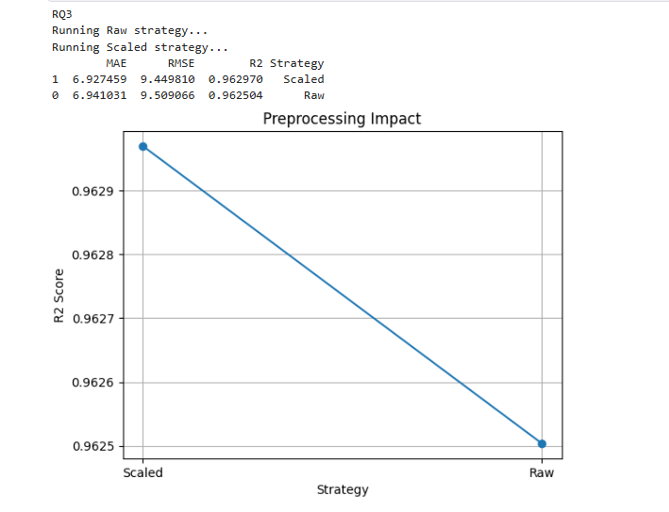

Research Question 4:- Feature Importance and Interpretability
Which features contribute most to predicting flight delays, and what insights can be derived?

# =============================
# LIMIT DATA (ADD THIS)
# =============================
df_sample = df.sample(15000, random_state=42)

# =============================
# FEATURES & TARGET (USE SAMPLE)
# =============================
X = df_sample.drop(columns=[target])
y = df_sample[target]

# =============================
# SPLIT
# =============================
X_train, X_test, y_train, y_test = train_test_split(
X, y, test_size=0.2, random_state=42
)

# =============================
# MODEL PIPELINE
# =============================
from sklearn.ensemble import RandomForestRegressor

pipe = Pipeline([
('prep', preprocessor),
('model', RandomForestRegressor(
n_estimators=50, # faster
max_depth=8,
random_state=42,
n_jobs=-1
))
])

pipe.fit(X_train, y_train)

# =============================
# FEATURE IMPORTANCE
# =============================
model = pipe.named_steps['model']
feature_names = pipe.named_steps['prep'].get_feature_names_out()

importance = model.feature_importances_

df_imp = pd.DataFrame({
'Feature': feature_names,
'Importance': importance
}).sort_values(by='Importance', ascending=False).head(10)

df_imp.to_csv("table4_feature_importance.csv", index=False)

# =============================
# PLOT
# =============================
plt.figure()
plt.barh(df_imp['Feature'], df_imp['Importance'])
plt.gca().invert_yaxis()
plt.title("Top Features")
plt.tight_layout()
plt.savefig("figure4_feature_importance.pdf")
plt.show()

output:-

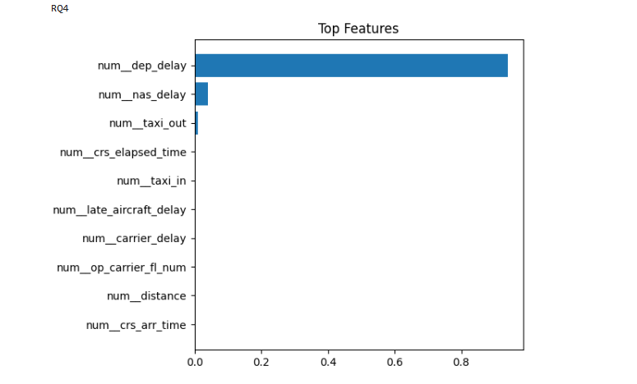

Research Question 5:- Sensitivity to Evaluation Metrics
How does model ranking change when evaluated using different performance metrics?

df = pd.read_csv("table2_model_comparison.csv")

df['Rank_R2'] = df['R2'].rank(ascending=False)
df['Rank_RMSE'] = df['RMSE'].rank()

df.to_csv("table5_metric_sensitivity.csv", index=False)

plt.figure()

for i in range(len(df)):
plt.plot(['R2', 'RMSE'],
[df.loc[i, 'Rank_R2'], df.loc[i, 'Rank_RMSE']],
marker='o', label=df.loc[i, 'Model'])

plt.legend()
plt.title("Ranking Sensitivity")
plt.savefig("figure5_metric_sensitivity.pdf")
plt.show()

output:-

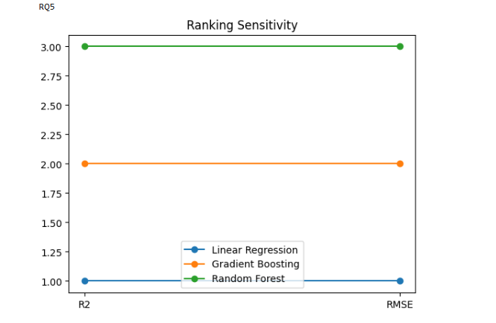

Research Question 6:- Robustness and Generalization
How stable is the selected model under different validation strategies and data perturbations?

from sklearn.model_selection import cross_val_score

# =============================
# SAMPLE FROM X, y (NOT df)
# =============================
sample_size = min(15000, len(X))

X_sample = X.sample(sample_size, random_state=42)
y_sample = y.loc[X_sample.index]

# =============================
# PIPELINE
# =============================
pipe = Pipeline([
('prep', preprocessor),
('model', RandomForestRegressor(
n_estimators=50,
max_depth=8,
random_state=42,
n_jobs=-1
))
])

# =============================
# CROSS-VALIDATION
# =============================
scores = cross_val_score(
pipe,
X_sample,
y_sample,
cv=5,
scoring='r2',
n_jobs=-1
)

print("Mean R2:", scores.mean())
print("Std R2:", scores.std())

output:-
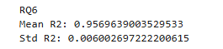

Research Question 7:- Practical Usefulness
How suitable is the final model for real-world deployment in airline operations?

df = pd.read_csv("table2_model_comparison.csv")

# Normalize scores
df['Score'] = df['R2'] - df['RMSE']/df['RMSE'].max()

df.to_csv("table7_final_decision.csv", index=False)

plt.figure()
plt.scatter(df['RMSE'], df['R2'])

for i in range(len(df)):
plt.text(df['RMSE'][i], df['R2'][i], df['Model'][i])

plt.xlabel("RMSE")
plt.ylabel("R2")
plt.title("Final Model Tradeoff")
plt.savefig("figure7_tradeoff.pdf")
plt.show()

Output:-
